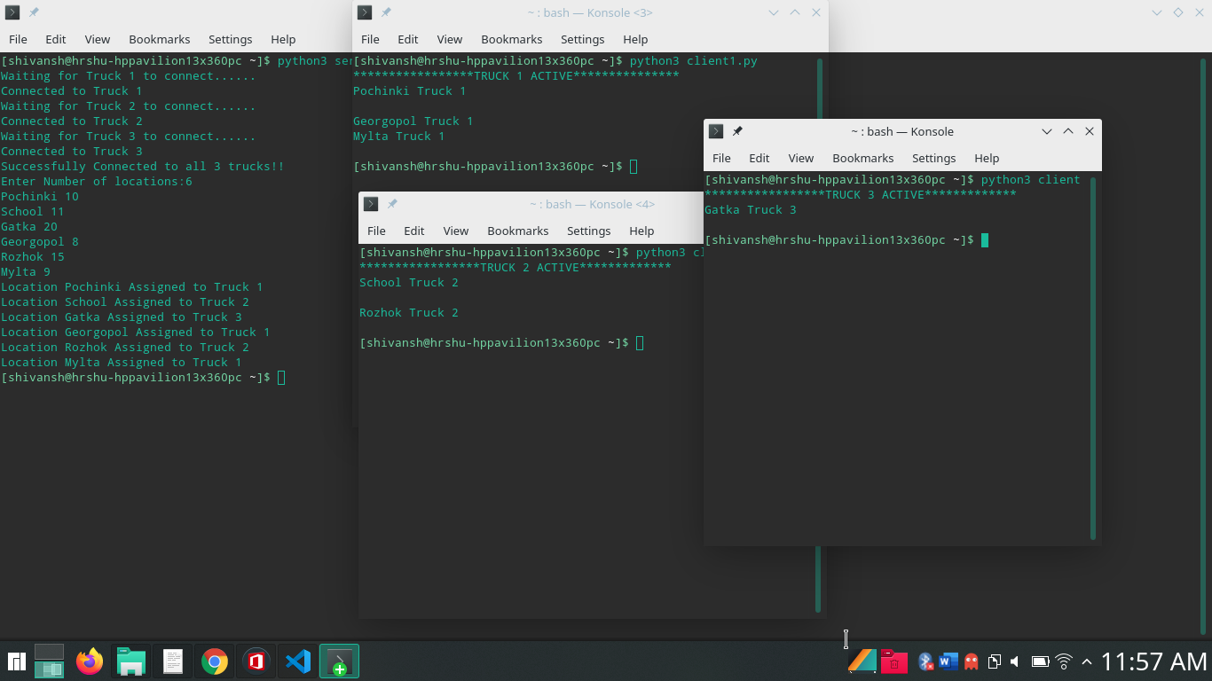

Github link: https://github.com/shivanshgoel-12/technocrats_summertask

Code:
Server side code:-

import socket
""" Connect to clients one by one as instructed by program"""

client=[]
s=['s1','s2','s3']
task=0
loc_dur=[]

## connect to users and stores all clients to a list
def accept_connections():
global client ## list of clients
global s ## a list of sockets
for i in range(3):
s[i]=socket.socket(socket.AF_INET,socket.SOCK_STREAM)
s[i].bind((socket.gethostname(),2000+i))
s[i].listen(5)
print(f"Waiting for Truck {i+1} to connect......")
clt,address1=s[i].accept()

''' .accept() functions waits for clients to connect'''

client.append(clt)
print(f"Connected to Truck {i+1}")
print("Successfully Connected to all 3 trucks!!")

## append delivery information to a output file
def write_output():
global f
f = open("myfile.txt", "a+")

## takes delivery locations information from user
def take_input():
global loc_dur
global n
n=int(input("Enter Number of locations:"))
for i in range(n):
loc_dur.append(input().split(" "))

""" assigns task to trucks based on their availability
availability order if all are free Truck1 > Truck2 > Truck3 """

'''
logic for assigning task
## run a loop till all tasks are finished
## n is number of tasks
## list of locations with time
while(task!=n):
if(time1==0): ## truck1 is free
##assgn location present at index 0 in list
## time1= time required for particular location
task=task+1 ## a task is completed
## remove location present on index 0 from the list
if(time2==0):
## truck2 is free
## assign a location
## time 2 = time required for partcular location
task=task+1
## one more task completed
if(time3==0):
## truck3 is free
## assign a location
## time3 =time required for particular location
task=task+1
## one more task completed
time1=time1-1 ## decrease time by -1 in every itteration
time2=time2-1
time3=time3-1
'''

def assigning_task():
global task
global loc_dur
global client
time1=0
time2=0
time3=0
while(task!=n):
if(time1==0):
print(f"Location {loc_dur[0][0]} Assigned to Truck 1")
time1=int(loc_dur[0][1])
client[0].sendall(bytes(str(loc_dur[0][0]+" Truck 1\n"),"ascii"))
f.write(str(loc_dur[0][0]+" Truck 1\n"))
loc_dur=loc_dur[1:]
task+=1

if(time2==0):
print(f"Location {loc_dur[0][0]} Assigned to Truck 2")
time2=int(loc_dur[0][1])
client[1].sendall(bytes(str(loc_dur[0][0]+" Truck 2\n"),"ascii"))
f.write(str(loc_dur[0][0]+" Truck 2\n"))
loc_dur=loc_dur[1:]
task+=1

if(time3==0):
print(f"Location {loc_dur[0][0]} Assigned to Truck 3")
time3=int(loc_dur[0][1])
client[2].sendall(bytes(str(loc_dur[0][0]+" Truck 3\n"),"ascii"))
f.write(str(loc_dur[0][0]+" Truck 3\n"))
loc_dur=loc_dur[1:]
task+=1

time1-=1
time2-=1
time3-=1

def main():
## function to accept all the connections from clients
accept_connections()
## takes input of delivery location
take_input()
## write assigned task information to output file
write_output()
## assign task to trucks based on availability
assigning_task()

if __name__=="__main__":
main()

client 1:-

import socket
s2=socket.socket(socket.AF_INET,socket.SOCK_STREAM)
s2.connect((socket.gethostname(),2000))
print("*****************TRUCK 1 ACTIVE***************")
while True:
k=s2.recv(1024).decode('ascii')
if(len(k)>0):
print(k)
else:
break
s2.close()

client2:-

import socket

s2=socket.socket(socket.AF_INET,socket.SOCK_STREAM)
s2.connect((socket.gethostname(),2001))
print("*****************TRUCK 2 ACTIVE*************")
while True:
k=s2.recv(1024).decode('ascii')
if(len(k)>0):
print(k)
else:
break
s2.close()

client3:-

import socket

s3=socket.socket(socket.AF_INET,socket.SOCK_STREAM)
s3.connect((socket.gethostname(),2002))
print("*****************TRUCK 3 ACTIVE*************")
while True:
k=s3.recv(1024).decode('ascii')
if(len(k)>0):
print(k)
else:
break
s3.close()

